

A minor project report on

**OBSTACLE DETECTOR USING ULTRA SONIC SENSOR**

Submitted by

ASHISH KUMAR ROY(1807258)

ASHUTOSH YADAV(1807259)

B DHEERAJ CHANDAN(1807265)

BISWAYAN BANERJEE(1807266)

PRIYA SAI MANOHAR (1807292)

Under the guidance of:

**Prof. Rishi Kumar Khanna**

**B.Tech. in Electronics and Electrical Engineering**

**School of Electronics Engineering**

**Kalinga Institute of Industrial Technology, Deemed to be University**

**Bhubaneswar, India**

**March 2021**

**CERTIFICATE**

This is to certify that the project report entitled

**OBSTACLE DETECTOR USING ULTRA SONIC SENSOR**

submitted by

|  |  |  |
| --- | --- | --- |
| ASHISH KUMAR ROY | **1807258** |  |
| ASHUTOSH YADAV | **1807259** |  |
| B DHEERAJ CHANDAN | **1807265** | image |
| BISWAYAN BANERJEE | **1807266** | 1610372883768 |
| PRIYA SAI MANOHAR | **1807292** |  |

In partial fulfillment of the requirements for the award of the **Degree of Bachelor of Technology in Electronics and Electrical Engineering** is a bonafide record of the work carried out under my(our) guidance and supervision at the School of Electronics Engineering, KIIT University.

Signature of Supervisor

Prof. Rishi Kumar Khanna

School of ElectronicsEngineering

KIIT DEEMED to beUNIVERSITY

**Acknowledgment**

We feel immense pleasure and feel privileged in expressing our deepest and most sincere gratitude to our supervisor **Prof. Rishi Kumar Khanna** for his excellent guidance throughout our project work. His kindness, dedication, hard work and attention to detail have been a great inspiration to us. Our heartfelt thanks to you Sir for the unlimited support and patience shown to us. We would particularly like to thank him for all his help in patiently and carefully correcting all our manuscripts.

We are also very thankful to and **prof.P.Biswal,** **Prof.M.Ramana** and **Prof.Suman Roy** our B.tech project coordinators (E&E), associate Dean **Prof.(Dr.) Amlan Datta** and **Prof. (Dr.) Suprava patnaik** Dean (School Of Electronics) for their support and suggestions during our course of the project work in the pre-final year of our undergraduate course.

|  |  |  |
| --- | --- | --- |
| ASHISH KUMAR ROY | **1807258** |  |
| ASHUTOSH YADAV | **1807259** |  |
| B DHEERAJ CHANDAN | **1807265** | image |
| BISWAYAN BANERJEE | **1807266** | 1610372883768 |
| PRIYA SAI MANOHAR | **1807292** |  |

**ABSTRACT**

Obstacle detection technique is a emerging technique for a last few years due to driverless vehicle or automated vehicles.This idea is to develop a prototype that detects the obstacles which is the focus of this paper.

Apart from this they also play vital role providing comfort zone for impaired.

Several types of equipment and approaches namely sensors, Computer Vision methods, micro-controllers etc. are used for detecting obstacles in the path. To enable the best collision free mobility of the users. we intend to use Ultrasonic sensors to detect and alert the user of any obstacle in the path. In this paper, the accuracy of detection of obstacles and estimating their distance from the user using ultra sonic sensors is determined.

In many applications like vehicle control, medical applications, robotic movement control, etc, distance measurement and detection of an object is used. This can be done using a variety of sensors- Ultrasonic, IR, radar, laser, etc.

Robotics department which is consider to be future replacement of the humans have a large dependency on these techiniques

Measurement using ultrasonic sensors is the cheapest and its reliability compared to others is very high. In this paper we discuss the ultrasonic sensors in distance measurement and detection in vehicle applications and compare them from a small prototype using arduino , to provide an output for obstacle detection.

**TABLE OF CONTENTS**

|  |
| --- |
| Chapter 1: INTRODUCTION |
| * 1. Objective of project     1.2 About ultra sonic sensor |
|  |

Chapter 2 : PROJECT COMPONENTS

2.1 Hardware Components

|  |  |
| --- | --- |
| 2.1.1 Arduino UNO R3  2.1.1(A) Technical Specifications    2.1.1(B) General Pin Functions  2.1.1(C) Communication   |  | | --- | | 2.1.2 Bread board    2.1.3 16X2 LCD Display    2.1.4 HC-SR04 ULTASONIC SENSOR    2.1.5 10k variable resistor trimmer Potentiometer |   2.1.6 Jumper cables |
| 2.1.7 Buzzer  2.1.8 Led |
|  |

2.2 Software Used

2.2.1 Arduino IDE 1.8

2.2.2 Proteus Design suite

Chapter 3: PROJECT ANALYSIS

|  |
| --- |
| 3.1 Circuit Diagram |
| 3.2 Project Description |

3.2.1 connecting HC-SR04 Ultra sonic sensor and arduino UNO R3 board

3.2.2 connecting LCD

3.2.3 connecting potentiometer

3.2.4 connecting Buzzer and led

3.2.5 supplying power by connecting arduino uno r3

3.3 Working

3.4 code

Chapter 4: DISCUSSIONS

4.1 Obstacle detection and its distance results in LCD (PROTOTYPE)

4.2 Obstacle detection and its distance results in LCD (PROTEOUS SIMULATION)

|  |
| --- |
| Chapter 5 : CONCLUSION AND SCOPE OF FURTHER WORK |
| 5.1 Summary    5.2 Future scope |
| 5.3 Weight Budget Analysis |
| 5.4 Cost Analysis |
| Chapter 6: PLANNING AND PROJECT MANAGEMENT  Chapter 7: REFERENCES |
| **LIST OF FIGURES**   |  |  |  | | --- | --- | --- | | **Figure No.** | **Description** | **Page No.** | | 2.1 | ARDUINO UNO R3 | 11 | | 2.2 | BREAD BOARD | 14 | | 2.3 | LCD DISPLAY | 16 | | 2.4 | ULTRASONIC SENSOR | 17 | | 2.5 | 10K VARIABLE RESISTOR TRIMMER POTENTIOMETER | 18 | | 2.6 | JUMPER WIRES | 18 | | 2.7 | PIEZ0 BUZZER | 19 | | 2.8 | LED | 19 | | 3.1 | CIRCUIT DIAGRAM | 21 | | 3.2 | ULTRASONIC WAVES ECHO | 23 | | 4.1 | RESULTS | 26,27 |   **CHAPTER 1**  **INTRODUCTION**   * 1. **OBJECTIVE OF PROJECT**   In this new era the development of world is going very fast.These includes Automobiles and transport system where the vehicles are increasing day by day and the human errors are increasing in the way of accidents.  Recent technological developments have made a lot of improvements in avoiding the accidents and save human life.  The obstacles which are the main reasons for accidents can be detected and accidents can be avoided. The obstacle detection in front or by the side of a moving vehicle is required in the current traffic scenario. The devices used to measure the distance may be small or large should be detected and alert user. There are various different kinds of sensors available to perform this. In most of the applications, low cost, accuracy of the devices and speed to be considered.  A simple approach for obstacle detection and alerting user in in any vehicle using ultrasonic sensor is discussed here.  The project is designed to develop obstacle detection with distance measurement system using ultrasonic waves and interfaced with arduino. We know that human audible range is 20hz to 20khz. We can utilize these frequency range waves through ultrasonic sensor HC-SR04.  The hardware part of ultrasonic sensor is interfaced with arduino. This method of detection is efficient way to detect small distances precisely. The distance of an obstacle from the sensor is measured through ultrasonic sensor.  **1.2 ABOUT ULTRA SONIC SENSOR**  An ultrasonic sensor is an electronic device that measures the distance of a target object by emitting ultrasonic sound waves, and converts the reflected sound into an electrical signal. Ultrasonic waves travel faster than the speed of audible sound (i.e. the sound that humans can hear).  Ultrasonic sensors have two main components:  1.The transmitter (which emits the sound using piezoelectric crystals)  2.The receiver (which receives the sound after it has travelled to and from the target). |

Ultrasonic sensors are also used as[level sensors](https://www.fierceelectronics.com/sensors/what-a-level-sensor) to detect, monitor, and regulate liquid levels in closed containers (such as vats in chemical factories). Most notably, ultrasonic technology has enabled the medical industry to produce images of internal organs, identify tumors, and ensure the health of babies in the womb.

For ultrasonic sensing, the most widely used range is 40 to 70 kHz. The frequency determines range and resolution; the lower frequencies produce the greatest sensing range. At 58 kHz, a commonly used frequency, the measurement resolution is one centimeter (cm), and range is up to 11 meters.

**CHAPTER 2**

**PROJECT COMPONENTS**

**2.1 HARDWARE COMPONENTS**

**2.1.1 ARDUINO UNO R3`**

The Arduino Uno is a microcontroller board based on the ATmega328. It has 20 digital input/output pins (of which 6 can be used as PWM outputs and 6 can be used as analog inputs), a 16 MHz resonator, a USB connection, a power jack, an in-circuit system programming header, and a reset button. It contains everything needed to support the micro controller simply connect it to a computer with a USB cable or power it with a [AC-to-DC adapter](https://www.pololu.com/product/1463) or battery to get started.

The Uno differs from all preceding boards in that it does not use the USB-to-serial driver chip. Instead, it features an ATmega16U2 programmed as a USB-to-serial converter. This auxiliary micro controller has its own USB bootloader, which allows advanced users to reprogram it.

This is the 3rd revision of the Uno (R3), which has a number of changes:

* The USB controller chip changed from ATmega8U2 (8K flash) to ATmega16U2 (16K flash). This does not increase the flash or RAM available to sketches.
* Three new pins were added, all of which are duplicates of previous pins. The I2C pins (A4, A5) have been also been brought out on the side of the board near AREF. There is a IOREF pin next to the reset pin, which is a duplicate of the 5V pin.
* The reset button is now next to the USB connector, making it more accessible when a shield is used.

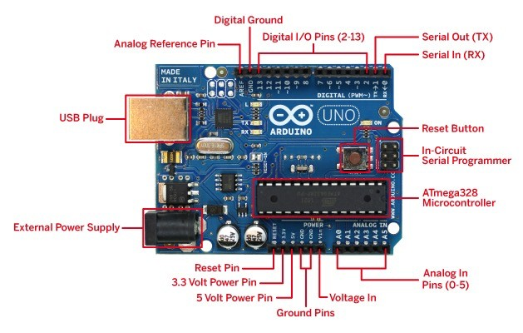

Fig 2.1 ARDUINO UNO R3

**2.1.1(a) TECHNICAL SPECIFICATIONS**

* Microcontroller: Microchip ATmega328P
* Operating Voltage: 5 Volts
* Input Voltage: 7 to 12 Volts
* Digital I/O Pins: 14 from D.1 to D.13 (of which 6 provide PWM output-D.3,D.5,D.6,D.9,D.10,D.11)
* Analog Input Pins: 6
* DC Current per I/O Pin: 40 ma
* DC Current for 3.3V Pin: 50 ma
* Flash Memory: 32 Kilo-Byte of which 0.5 Kilo-Byte is used by bootloader
* SRAM: 2 KB(ATmega328p)
* EPROM: 1 KB
* Clock Speed: 16 MHz
* Length: 68.6 mm
* Width: 53.4 mm
* Weight: 25 g

**2.1.1(b) GENERAL PIN FUNCTIONS**

|  |  |  |
| --- | --- | --- |
| **Pin Category** | **Pin Name** | **Details** |
| Power | Reset | Vin: Input voltage to Arduino when using an external power source.  5V: Regulated power supply used to power microcontroller and other components on the board.  3.3V: 3.3V supply generated by on-board voltage regulator. Maximum current draw is 50mA.  GND: ground pins. |
| Reset | A0 – A5 | Resets the microcontroller. |
| Analog Pins | Digital Pins 0 - 13 | Used to provide analog input in the range of 0-5V |
| Input/Output Pins | 0(Rx), 1(Tx) | Can be used as input or output pins. |
| Serial | 2, 3 | Used to receive and transmit TTL serial data. |
| External Interrupts | 3, 5, 6, 9, 11 | To trigger an interrupt. |
| PWM | 10 (SS), 11 (MOSI), 12 (MISO) and 13 (SCK) | Provides 8-bit PWM output. |
| SPI | 13 | Used for SPI communication. |
| Inbuilt LED | A4 (SDA), A5 (SCA) | To turn on the inbuilt LED. |
| TWI | AREF | Used for TWI communication. |
| AREF | AREF | To provide reference voltage for input voltage. |

**2.1.1(c) COMMUNICATION**

Arduino will be used to communicate with a system, another arduino board or different microcontrollers. The ATmega328P microcontroller provides (5V) serial communication which might be done using digital pin 0, D.0 and digital pin 1, D.1. An ATmega16U2 that has firmware pre-installed in it for the transfer of data from computer to ATMega328 and vice-versa channels this serial communication over USB and seems as a virtual comport to software-package on the system. The aTmega16U2 computer code uses the regular USB COM drivers, and no external driver is required. Furthermore, on Windows operating system, a .inf file is reqiured. The arduino package includes a serial monitor that permits easy textual piece of informaton-data to be sent to and from the arduino board. There are 2 receiving and transmitting Light Emitting Diode on the arduino board which will flash once the information-data is transmitted via the USB-to-serial chip and USB interaction to the system . A Software-Serial library permits for serial communication on any of the Uno's digital pins. The aTmega328P furthermore supports I2C and SPI communication. The arduino package includes a Wide library to alter the utilization of the I2C bus.

**2.1.2 BREAD BOARD**

A breadboard is a solderless device for small prototype with electronics and test circuit designs. Most electronic components in electronic circuits can be interconnected by inserting their terminals into the holes and then making connections through wires.

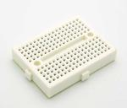

Fig 2.2 BREAD BOARD

**2.1.3 16X2 LCD DISPLAY**

LCD modules are very commonly used in most embedded projects, the reason being its cheap price, availability and programmer friendly. Most of us would have come across these displays in our day to day life, either at PCO’s or calculators. The pinouts have already been visualized above now let us get a bit technical.

**16×2 LCD** is named so because; it has 16 Columns and 2 Rows. There are a lot of combinations available like, 8×1, 8×2, 10×2, 16×1, etc. but the most used one is the 16×2 LCD. So, it will have (16×2=32) 32 characters in total and each character will be made of 5×8 Pixel Dots.

### ****Features of 16×2 LCD module****

* Operating Voltage is 4.7V to 5.3V
* Current consumption is 1mA without backlight
* Alphanumeric LCD display module, meaning can display alphabets and numbers
* Consists of two rows and each row can print 16 characters.
* Each character is build by a 5×8 pixel box
* Can work on both 8-bit and 4-bit mode
* It can also display any custom generated characters
* Available in Green and Blue Backlight

|  |  |  |
| --- | --- | --- |
| **Pin No:** | **Pin Name:** | **Description** |
| 1 | Vss (Ground) | Ground pin connected to system ground |
| 2 | Vdd (+5 Volt) | Powers the LCD with +5V (4.7V – 5.3V) |
| 3 | VE (Contrast V) | Decides the contrast level of display. Grounded to get maximum contrast. |
| 4 | Register Select | Connected to Microcontroller to shift between command/data register |
| 5 | Read/Write | Used to read or write data. Normally grounded to write data to LCD |
| 6 | Enable | Connected to Microcontroller Pin and toggled between 1 and 0 for data acknowledgement |
| 7 | Data Pin 0 | Data pins 0 to 7 forms a 8-bit data line. They can be connected to Microcontroller to send 8-bit data.  These LCD’s can also operate on 4-bit mode in such case Data pin 4,5,6 and 7 will be left free. |
| 8 | Data Pin 1 |  |
| 9 | Data Pin 2 |  |
| 10 | Data Pin 3 |  |
| 11 | Data Pin 4 |  |
| 12 | Data Pin 5 |  |
| 13 | Data Pin 6 |  |
| 14 | Data Pin 7 |  |
| 15 | LED Positive | Backlight LED pin positive terminal |
| 16 | LED Negative | Backlight LED pin negative terminal |

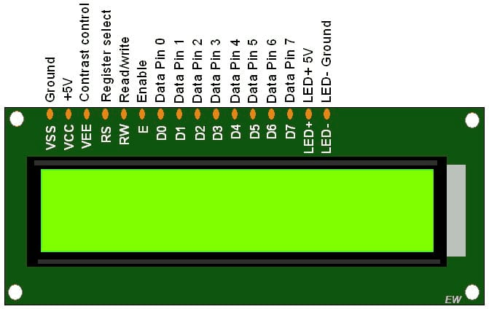

Fig 2.3 LCD DISPLAY

**2.1.4 HC-SR04 ULTRA SONIC SENSOR**

the HC-SR04 Ultrasonic distance sensor consists of two [ultrasonic transducers](https://en.wikipedia.org/wiki/Ultrasonic_transducer). The one acts as a transmitter which converts electrical signal into 40 KHz ultrasonic sound pulses. The receiver listens for the transmitted pulses. If it receives them it produces an output pulse whose width can be used to determine the distance the pulse travelled.

The sensor is small, easy to use in any robotics project and offers excellent non-contact range detection between 2 cm to 400 cm with an accuracy of 3mm. Since it operates on 5 volts, it can be connected directly to an Arduino or any other 5V logic microcontrollers.

Here are complete specifications:

|  |  |
| --- | --- |
| Operating Voltage | DC 5V |
| Operating Current | 15mA |
| Operating Frequency | 40KHz |
| Max Range | 4m |
| Min Range | 2cm |
| Ranging Accuracy | 3mm |
| Measuring Angle | 15 degree |
| Trigger Input Signal | 10µS TTL pulse |
| Dimension | 45 x 20 x 15mm |

The HC-SR04 ultrasonic range finder has four pins:

* **Vcc** – supplies the power to generate the ultrasonic pulses
* **GND** – connected to ground
* **Trig** – where the Arduino sends the signal to start the ultrasonic pulse
* **Echo** – where the ultrasonic range finder sends the information about the duration of the trip taken by the ultrasonic pulse to the Arduino

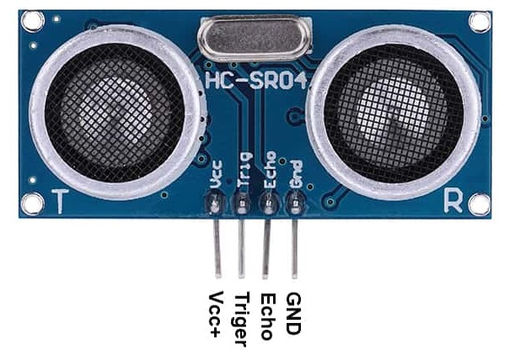

Fig 2.4 ULTRA SONIC SENSOR

**2.1.5 10K VARIABLE RESISTOR TRIMMER POTENTIOMETER**

Trimpot is a high accuracy variable resistor and mountable with 3 terminal pins. The Variable resistors are used for varying the voltage as per the need in a circuit. The outer two pins are connected to Vcc and 0V, and center pin outputs a variable volatge between 0v and Vcc .

**Specifications:-**

* Track Resistance: 10K ohm
* Resistance Tolerance: ± 5%
* Temperature Coefficient: ± 50ppm/°C
* Potentiometer Mounting: Through Hole
* Adjustment Type: Top
* Contact Resistance Variation +: 1%
* Full Power Rating Temperature: 85°C
* Lead Diameter: 0.5mm
* Operating Temperature Range: -55°C to +125°C
* Resistance: 10K ohm
* Resistor Element Material: Variable Rotary Trimmer

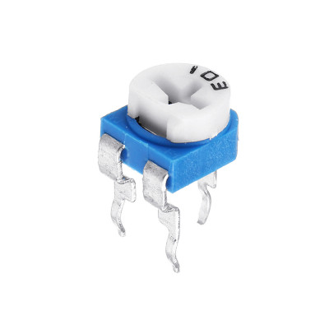

Fig 2.5 10K VARIABLE RESISTOR TRIMMER POTENTIOMETER

**2.1.6 JUMPER WIRES**

Jumper wires are simply wires that have connector pins at each end, allowing them to be used to connect two points to each other without soldering. Jumper wires are typically used with [breadboards](https://blog.sparkfuneducation.com/what-is-a-breadboard) in order to make it easy to change a circuit as needed.

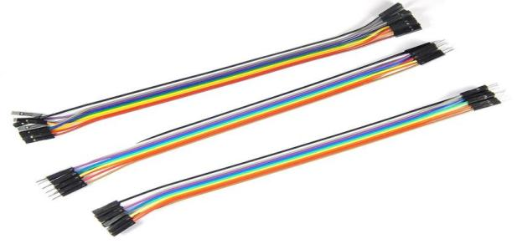

Fig 2.6 JUMPER WIRES

**2.1.7 PIEZ0 BUZZER**

A piezo buzzer is a type of electronic device that's used to produce a alarm or sound.

**Piezo Buzzer Characteristics**

* Wide operating voltage: 3~250 V.
* Lower current consumption: less than 30 mA higher rated frequency.
* Larger footprint.
* Higher **sound** pressure level.

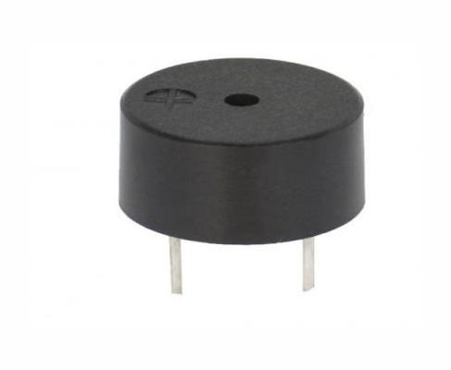

Fig 2.7 PIEZ0 BUZZER

**2.1.8 LED**

A light-emitting diode (**LED**) is a [semiconductor](https://en.wikipedia.org/wiki/Semiconductor" \o "Semiconductor) [light source](https://en.wikipedia.org/wiki/Light_source" \o "Light source) that emits light when [current](https://en.wikipedia.org/wiki/Electric_current" \o "Electric current) flows through it.

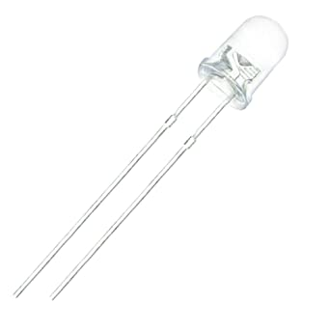

Fig 2.8 LED

**2.2 SOFT WARE USED**

**2.2.1 ARDUINO IDE**

The Arduino integrated development atmosphere (IDE) is such an application that may be deployed across several platforms like Windows, mac OS and UNIX operating system, Java being the artificial language. It is used to write and transfer programs to Arduino compatible boards. However with the help of third party cores, it also can be used to transfer codes to alternative merchant development boards.

The languages supported by the Arduino IDE square measure primarily C and C++ , additionally to that special rules of code structuring square measure used, as could also be compatible.

User-written code includes 2 basic functions, one for beginning the sketch and also the alternative one being the most program loop, that square measure compiled and joined with a program stub main() into an feasible cyclic computer programme with the help of wildebeest tool-chain, that's enclosed with the IDE distribution.

The Arduino IDE uses the program avrdude to perform the conversion of feasible code into a document in hex that's finally loaded into the Arduino board , that a loader program within the board's code is used.

**2.2.2 PROTEUS DESIGN SUITE**

The **Proteus Design Suite** is a proprietary software tool suite used primarily for [electronic design automation](https://en.wikipedia.org/wiki/Electronic_design_automation" \o "Electronic design automation). The software is used mainly by electronic [design engineers](https://en.wikipedia.org/wiki/Design_engineer" \o "Design engineer) and technicians to create [schematics](https://en.wikipedia.org/wiki/Schematic" \o "Schematic) and electronic prints for manufacturing [printed circuit boards](https://en.wikipedia.org/wiki/Printed_circuit_board" \o "Printed circuit board).

**CHAPTER 3**

**PROJECT ANALYSIS**

**3.1 CIRCUIT DIAGRAM**

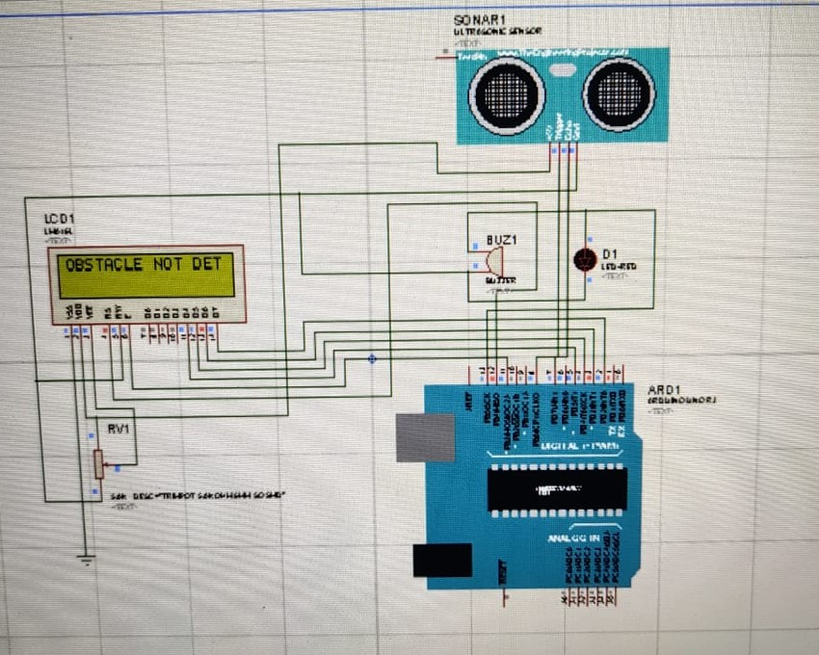

**Fig 3.1 : Circuit Connection of ultra sonic sensor and lcd display and arduino uno R3 and piezo buzzer and led**

**3.2 PROJECT DESCRIPTION**

**3.2.1 CONNECTING HC -SR04 ULTRA SONIC SENSOR TO ARDUINO R3 BOARD**

Vcc pin with +5 volts

Trigger pin with with digital pin 13 of Arduino UNO board

Echopin with with digital pin 8 of Arduino UNO board

GND pin with GND pin of Arduino UNO board

**3.2.2 CONNECTING LCD**

Vss with GND pin of Arduino UNO board

Vdd with +5 volts.

Vo with middle pin of potentiometer

RS with digital pin 12 of Arduino UNO board

RW with GND pin of Arduino UNO board

E with digital pin 11 of Arduino UNO board

D4 with digital pin 5 of Arduino UNO board

D5 with digital pin 4 of Arduino UNO board

D6 with digital pin 3 of Arduino UNO board

D7 with digital pin 2 of Arduino UNO board

A with +5 volts

K with ground pin of Arduino UNO board

**3.2.3 CONNECTING POTENTIOMETER**

Left pin with +5 volt supply

Middle pin with LCD PIN V0

Right pin with GND pin of Arduino UNO board

**3.2.4 CONNECTING BUZZER AND LED**

Positive terminal to pin 13 of Arduino

Negative terminal to GND

**3.2.5 SUPPLYING POWER BY CONNECTING ARDUINO UNO R3**

For this project, we can supply power to the Arduino through any +5V power source. You can use a USB port from your computer to power the Arduino

**3.3 WORKING**

The main working of the project is based on ultra sonic sensor

An ultrasonic sensor houses a transducer that emits high-frequency, inaudible acoustic waves in one direction ultrasounds at 40 000 Hz which travels through the air when the transducer element vibrates. If the waves strike and bounce off an object, the transducer receives the echoed signal. Considering the travel time and the speed of the sound you can calculate the distance.

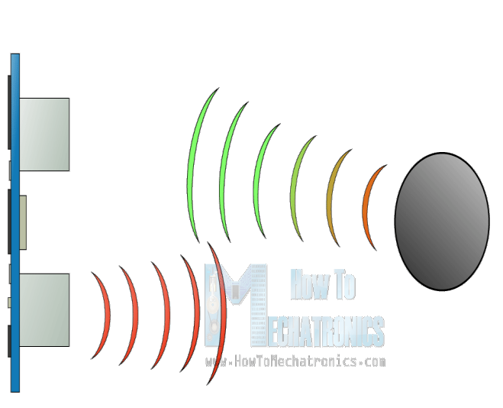

Fig 3.2 ULTRASONIC WAVES ECHO

The microcontroller is used to generate 40 kHz sound pulse. It reads when the echo arrives; it finds the time taken in microseconds for to and from travel of sound waves. Using velocity of 330 m/s, it does the calculations and shows on the LCD Module and display the object detected and distance in centimeters.

The on-chip Flash allows the program memory to be reprogrammed in-system or by a conventional nonvolatile memory programmer. By combining a versatile 8-bit CPU with In-System Programmable Flash on a monolithic chip, the powerful micro controller which provides a highly cost effective solution to many control applications. By measuring the time taken for the whole process, it will use the arithmetic operation that has been programmed in micro controller in order to obtain the distance.

Lastly, When the object detects the buzzer makes sound and led blinks to alert user.the output will be display at LCD Module.

**3.4 CODE**

#define trigPin 8 // defining trigpin of UV semsor

#define echopin 7 // defining echopin of UV semsor

#include<LiquidCrystal.h> // headerfile for LCD screen display

LiquidCrystal lcd{12,11,5,4,3,2}; // Declaring LCD pins

void setup()

{ // put your setup code here, to run once:

Serial.begin(9600);

pinMode(13,OUTPUT);

pinMode(trigPin,OUTPUT); // Declaring trigpin as output pin

pinMode(6,OUTPUT);

pinMode(echopin,INPUT); // Declaring echopin as input pin

lcd.begin(16,2); // LCD disply having 16 rows and 2 coloumns

Serial.begin(9600); //To exchange messages with serial monitor at a rate of 9600 bits per second

}

void loop()

{ // put your main code here, to run repeatedly:

long distance,time; // Declare variables distance and time

digitalWrite(trigPin,LOW); //sends high signal frequency....

delay (1000); // ...for every 1 second

digitalWrite(trigPin,HIGH); //singal reflects back....

delay (1000); // ...for every 1 second

digitalWrite(trigPin,LOW); //send high signal frequency to the echopin

time = pulseIn(echopin,HIGH); //If echo pin recieves signal we can calculate time

distance=(time/2)*0.03435; // finding distance using time

analogWrite(6,120);

if(distance>300)

{

lcd.setCursor(0,0); // for displaying on 1st coloumn of LCD screen

lcd.print("OBSTACLE DETECTED"); // Text to be displayed on LCD screen

lcd.setCursor(0,1); // for displaying on 2nd coloumn of LCD screen

lcd.print(distance); // value to be displayed on LCD screen

lcd.print(" cm"); // to print units

digitalWrite(13,HIGH); //LED ON

}else{

lcd.setCursor(0,0); // for displaying on 1st coloumn of LCD screen

lcd.print("OBSTACLE NOT DETECTED"); // Text to be displayed on LCD screen

lcd.setCursor(0,1); // for displaying on 2nd coloumn of LCD screen

lcd.print(distance); // value to be displayed on LCD screen

lcd.print(" cm "); // to print units

digitalWrite(13,LOW); //LED OFF

}

delay (100);

}

**CHAPTER 4**

**DISCUSSIONS**

**4.1 OBSTACLE DETECTION AND ITS DISTANCE RESULTS IN LCD(PROTOTYPE)**

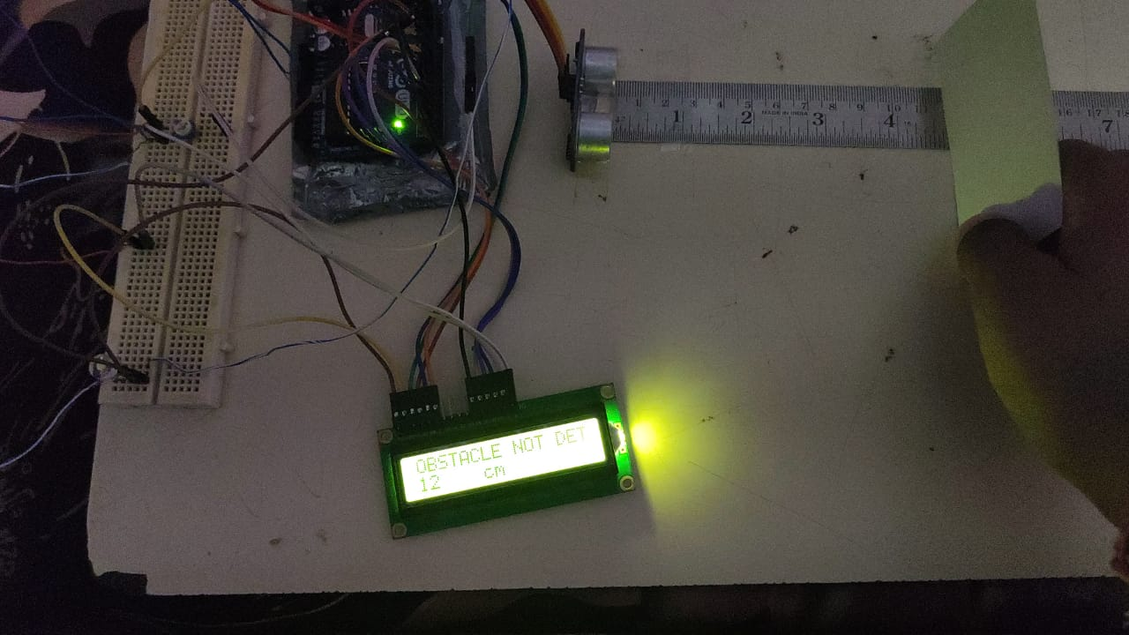

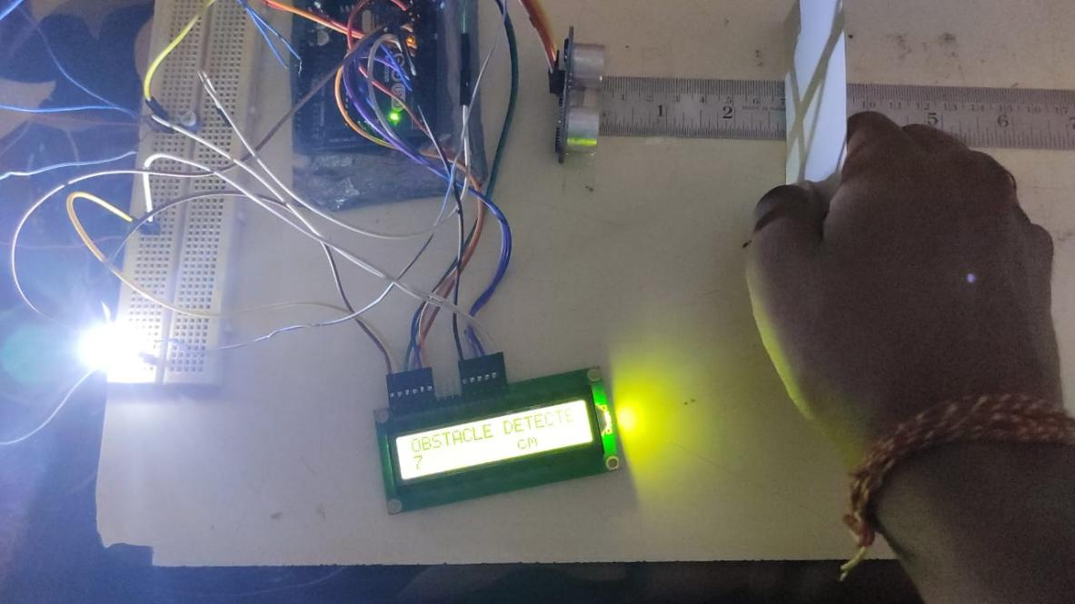

**4.2 OBSTACLE DETECTION AND ITS DISTANCE RESULTS IN LCD**

**(PROTEOUS SIMULATION)**

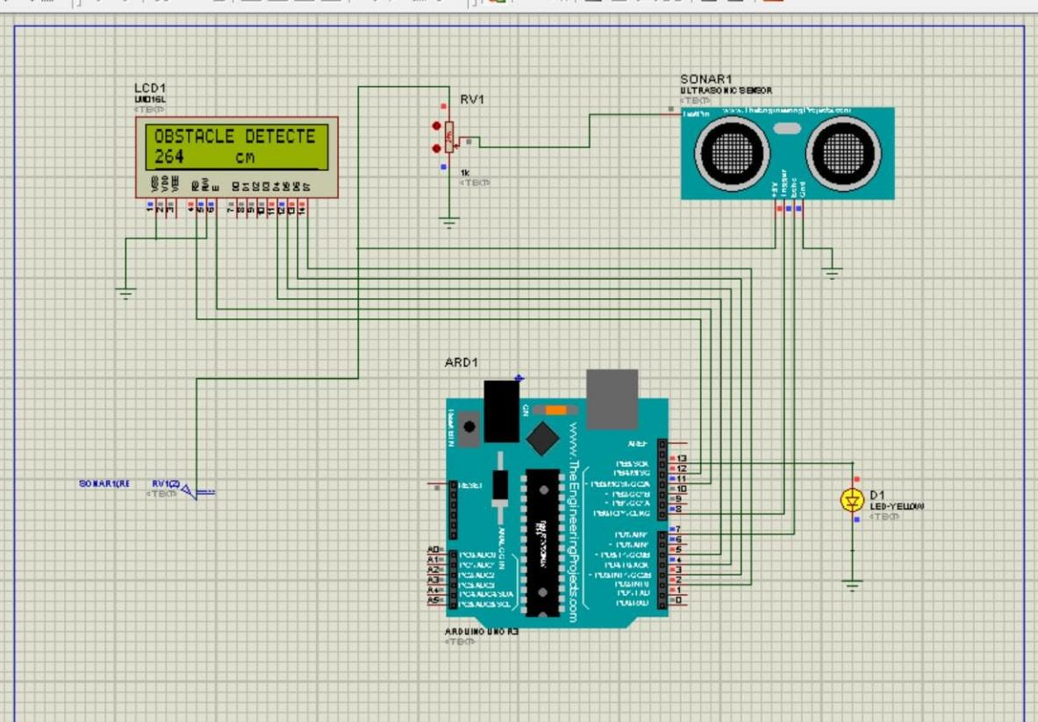

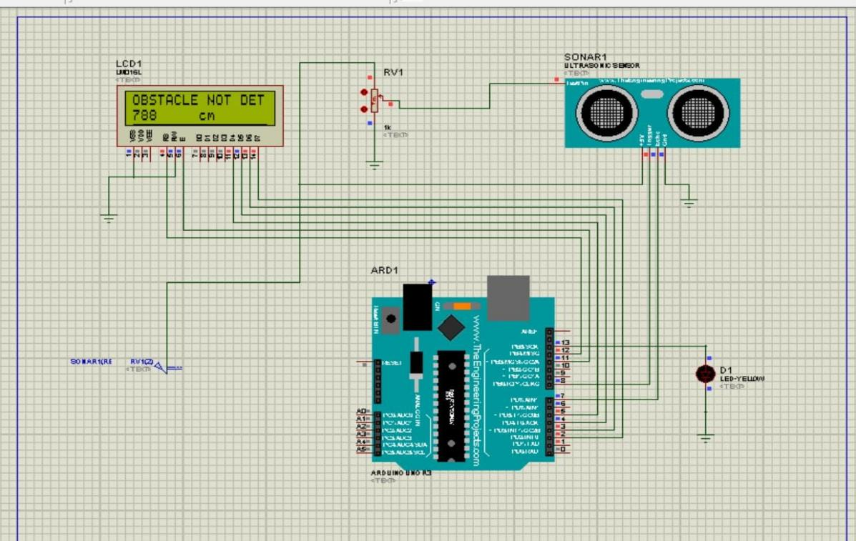

**CHAPTER 5**

**CONCLUSION AND SCOPE OF FUTURE WORK**

**5.1 SUMMARY**

The detecting an obstacle and alerting system is discussed in this paper. The methodology employs a distance measurement sensor namely ultrasonic sensor which detects the range of the obstacle and Arduino processes it to alert the vehicle users to avoid the possible accidents.

Obstacle detection is a very good application to be used in vehicles, preventing many accidents and loss of life

**5.2 FUTURE SCOPE**

The obstacle detection sysytem plays a crucial role in implementing and deploying autonomus driving on our roads.Not only the ultra sonic sensors the emerging technology like LIDAR,RADAR,VISION CAMERAS AND IR are the new capabalities and the behaviour in a number of different situations like during night ,day time and extreme weather conditions,in urban areas in the presence of smooth surfaces ,in situation where emergency service vehicles to be detected and recognised ,in situation like potholes to be observed .In these type of situation the human errors are common to over come those we can use the obstacle detection

We can say that by these technolgies the obstacle detection gives a more accurate representation of the driving environment

**5.3 WEIGHT BUDGET ANALYSIS**

|  |  |  |  |  |
| --- | --- | --- | --- | --- |
| **S.no.** | **Item** | **Weight** | **Qty** | **Total** |
| 1. | Arduino UNO R3 | 25 grams | 1 | 25 grams |
| 2. | BREAD BOARD | 400 grams | 1 | 400 grams |
| 3. | 16 X 2 LCD DISPLAY | 35 grams | 1 | 35 grams |
| 4. | HC-SR04 ULTRA SONIC SENSOR | 10 grams | 1 | 10 grams |
| 5. | 10K VARIABLE RESISTOR TRIMMER POTENTIOMETER | 5 grams | 1 | 5grams |
| 6. | JUMPER CABLES | 10 grams | 3 | 30 grams |
| 7. | BUZZER | 5grams | 1 | 5 grams |
| 8. | LED | 1 gram | 1 | 1 gram |
|  | TOTAL |  |  | 511grams |

**5.4 COST ANALYSIS**

|  |  |  |  |
| --- | --- | --- | --- |
| **S.no.** | **Item** | **Qty** | **Total** |
| 1. | Arduino UNO R3 | 1 | 500 RS |
| 2. | BREAD BOARD | 1 | 138 RS |
| 3. | 16 X 2 LCD DISPLAY | 1 | 200 RS |
| 4. | HC-SR04 ULTRA SONIC SENSOR | 1 | 125 RS |
| 5. | 10K VARIABLE RESISTOR TRIMMER POTENTIOMETER | 1 | 40 RS |
| 6. | JUMPER CABLES | 3 | 115 RS |
| 7. | BUZZER | 1 | 30RS |
| 8. | LED | 1 | 10RS |
|  | TOTAL | 10 | 1158RS |

**CHAPTER 6**

**PLANNING AND PROJECT MANAGEMENT**

|  |  |  |  |
| --- | --- | --- | --- |
| **S.No.** | **activity** | **Starting Week** | **Number of Weeks** |
| 1. | Literature Review | 1st - 2nd week of February | 2 |
| 2. | Project Finalization | 3rd week of February | 1 |
| 3. | Permission for required software | 4th week of  February | 1 |
| 4. | Gathering of Hardware & Formation of codes | 1st week of march | 1 |
| 5. | Hardware assembly calibration | 2nd week of march | 1 |
| 6. | Code Integration &  Inclusion of arduino module | 3rd week of march | 1 |
| 7. | Testing/Modification of Working model | 4th week of  march | 1 |
| 8. | Preparation of project report | 1st week of  april | 1 |
| 9. | Preparation of Project presentation | 2nd week of april | 1 |

**The Gantt Chart is shown below -**

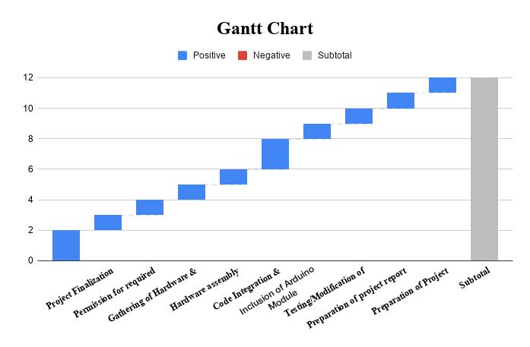

**CHAPTER 7**

**REFERENCES**

https://www.maxbotix.com/articles/how-ultrasonic-sensors-work.htm

https://en.wikipedia.org/wiki/Liquid-crystal_display

https://www.instructables.com/Obstacle-Detector-Using-Ultrasonic-Distance-Sensor/

<https://www.researchgate.net/publication/337842014_Obstacle_detection_using_ultrasonic_sensor_for_a_mobile_robot>

<https://www.circuitbasics.com/how-to-set-up-an-ultrasonic-range-finder-on-an-arduino/>

<https://www.arduino.cc/>

<https://youtu.be/6F1B_N6LuKw>

**SELF DECLARATION FOR PLAGIARISM CHECK**

We, ASHISH KUMAR ROY(1807258**),**ASHUTOSH YADAV(1807259**),**B DHEERAJ CHANDAN(1807265**),**BISWAYAN BANERJEE(1807266**),**PRIYA SAI MANOHAR(1807292**)**are declaring that our Project report on “ OBSTACLE DETECTOR USING ULTRA SONIC SENSOR” has plagiarism well within the limits prescribed to us. We take the full responsibility of it.